Africom ZISPA domain registration Manual for **regdns-txt** **RC1**

1. Visit <http://casper.dnsreg.ai.co.zw/>
2. You will see a form like below and just go with the flow ….

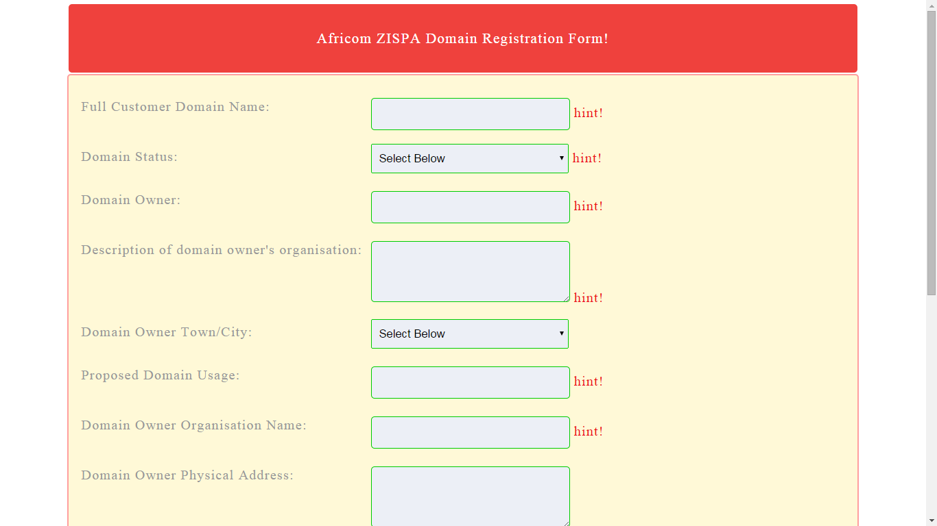

1. On submitting the form ,it will take you to this screen

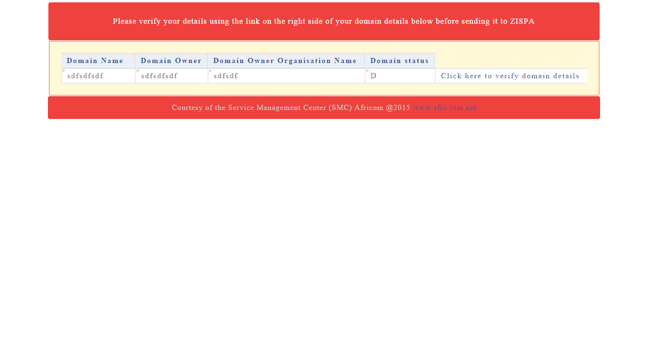

1. And if you pay attention to detail (like everyone else at Africom) ….. you just read through the comments and hints on the form and you will be fine
2. Next screenshot after clicking “**Click here to verify domain details**” ,you will see something like this
3. 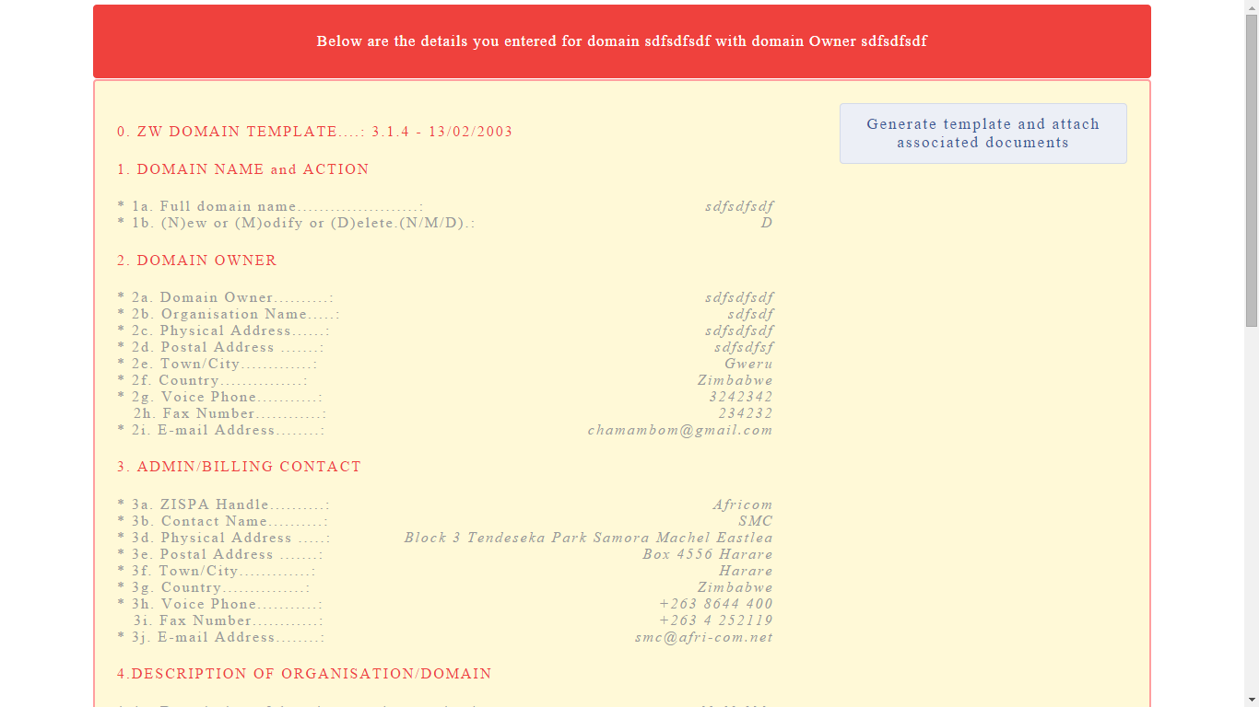
4. Like I said ,if you read all the comments, you won’t be lost and on the form above , click “**Generate template and attach associated documents**”
5. And this will Generate your template and the template will already be attached as shown by the form below 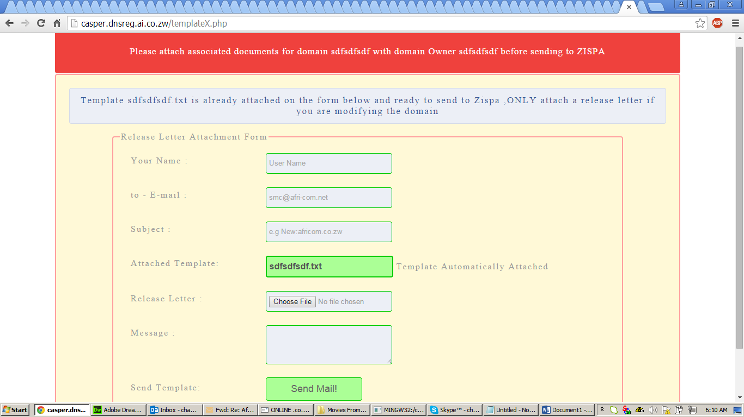
6. And this part is self-explanatory

* **Your name** : that’s your name .e.g. David Njanje or Progress Nyahuma or Yolanda Banda
* **To-Email** : This is where you have to input **ZISPA email address** [For test purposes , use your **Africom email address** here to see how the template is going to be like]
* Subject : **just type New: or Modify : or Delete:** but for now ,let’s concentrate on just **New:**
* **Attached template** : this part leave as is
* **Release letter** : (For now ,you don’t need this part)
* **Message** : Just type **Register or Modify or Delete**
* **Then finally send your template and that’s it**

**Still work in progress below**

1. **Intergrate the process with our 4 DNS servers**
2. **Intergrate the process with ZISPA DNS servers [this will automatically query ZISPA records to see if the domain DOES NOT ALREADY EXIST]**
3. **When template is sent to a Gmail address ,the email goes to spam folder**
4. **Strong email validation so that the email form prevents spamming zispa**